SACSCOC HIGHLIGHTS
- QEP Leadership Team members Amy Gustavson, Scott Byington, and Constance Boahn presented at the 2019 SACSCOC Annual Meeting in Houston, TX in December. Their presentation was entitled “Embracing the QEP as a Campus-Wide Continuous Improvement Activity.”

- Constance Boahn, Scott Byington, Dr. Lisa Chapman, Amy Gustavson, Dr. Brian Merritt, and Dr. Linda Scuiletti attended the 2019 SACSCOC Annual Meeting in December. Attendees attended presentations on accreditation, new SACSCOC standards, the fifth-year interim report, and substantive change.

- According to the newly released, finalized U.S. Department of Education negotiated rulemaking process, there will be NO MORE Regional or National accreditors – and no more geographic boundaries. All institutions of higher education will be free to pursue accreditation with any of the DOE authorized accreditors. SACSCOC is still working on the details on managing this process; more information will be forthcoming.

- There are new, enhanced expectations for Comprehensive Standard 8.1 –
  - All student success data must be disaggregated by demographics/race/ethnicity/additional categories that make sense for each college
  - All success metrics must include targets and measures undertaken for improvement (closing the loop)

- Details on the newly approved Differentiated Review process will be rolled out soon. This process will allow for a streamlined reaffirmation process for those institutions that have maintained a clean record with SACSCOC and meet certain other criteria.

SACSCOC CORRESPONDENCE
SACSCOC Approves Submissions, Provides Guidance
- October 21, 2019: SACSCOC sent an email notice to all member institutions about a Call for Vote on a SACSCOC Differentiated Review Process Policy to be held at the 2019 SACSCOC Annual Meeting. While maintaining the rigor associated with the reaffirmation of accreditation process, member institutions may participate in a Differentiated Review Process if they meet eligibility requirements. All member institutions that meet the eligibility criteria would be allowed to complete a modified Compliance Certification document consisting of 40 Core Requirements and Standards instead of 73 Core Requirements and Standards. We are hopeful that, given our good track records, we may be eligible to participate.
- November 1, 2019: SACSCOC sent an email to all member institutions with an attached letter response from the Council of Regional Accrediting Commissions (C-RAC) in regards to the College Affordability Act (ACA) as approved in the House and Labor Committee in October 2019. The federal Department of Education is shifting some of the accreditors’ authority to themselves and the states. There will be increased emphasis on student achievement, academic quality, and disaggregating/benchmarking of student outcomes.
- November 22, 2019: SACSCOC approved the Chatham Health Sciences Center off-campus instructional site (OCIS). Initially, the following approved, existing programs will be available at the site: Health & Fitness Science, Medical Assisting, and Nurse Aide.
- November 26, 2019: SACSCOC sent an email confirming the submission of CCCC’s 2019 SACSCOC Financial Profile and Indicators on July 9, 2019.
- November 27, 2019: CCCC submitted a letter and teach out plan to close the Medical Assisting program at Chatham Main Campus and relocate it to the Chatham Health Sciences Center.
- December 9, 2019: During a face-to-face meeting, SACSCOC VP Dr. John Hardt conveyed to Dr. Scuiletti and Dr. Merritt that the SACSCOC Board of Trustees has accepted CCCC’s submission of our substantive change policy, including evidence that the policy is written, approved, published, accessible, implemented, and enforced on an ongoing basis. No further information is required.

The Commission had requested the submission because CCCC had previously interpreted SACSCOC’s Sub Change Policy differently than SACSCOC intended. SACSCOC requires that a college obtain prior approval for all curriculum instructional sites offering 50% or more of any curriculum program. At seven service area high schools, the ability to complete 50% or more of credit is due solely to the availability of distance education coursework. The College had not previously considered these sites to be off-campus instructional sites since it had no requirement with regard to where its distance education students must be physically present to access distance education instruction. However, students are required by their high school principals to work on their distance education coursework in a high school computer lab or classroom.

Following clarification that when work on distance education coursework is required at the high school, the distance education coursework must be considered to be provided onsite, the College submitted a modified prospectus to align with this interpretation of the SACSCOC substantive change policy. SACSCOC approved these seven high schools as off-campus instructional sites in May.

- January 15, 2020: CCCC submitted the annual SACSCOC Profile for Enrollment and General Information.

QEP HIGHLIGHTS

QEP Implementation Continues
Quality Enhancement Plan team members continue to make progress on our My Academic Pathway project which is aimed at providing a personalized approach that enables new students to make efficient, effective, and timely choices in order to complete their educational and career goals. The essential elements of the project are providing enhancements to Admissions, ACA courses, and Advising.
The project goals are to:

- Enable each student to select an appropriate academic program,
- Consistently enhance each student’s pathway to goal completion, and
- Facilitate timely completion of each student’s academic goals.

Highlights this quarter include:

- Amy Gustavson, Assistant Director of Institutional Effectiveness & QEP, shared highlights of the QEP’s two-year progress at the Arts, Sciences and Advising Division meeting on January 8, 2020.

- The M.A.P. Marketing Team sponsored a table at CCCC’s Club Day on January 14, 2020. Students received a copy of the My Success Checklist and Student Services guide for the Lee Main Campus. Volunteers included Summerlin Webb, Amy Gustavson, and Nick Testa. They reviewed the importance of completing tasks each semester in order to ensure that students stay on their pathway and complete their academic journey. Students participated in a short survey/scavenger hunt and were entered into a raffle.

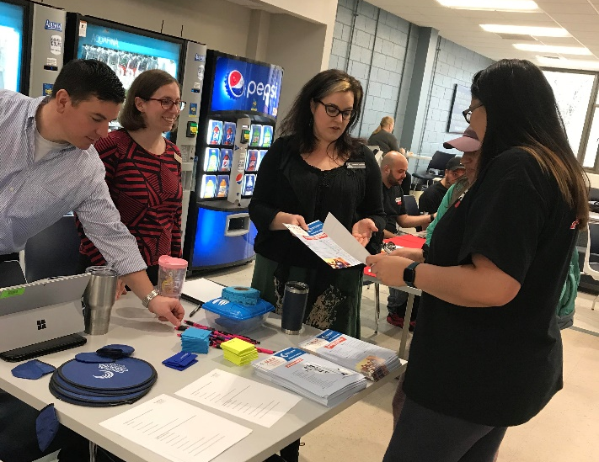

The third edition of the My Academic Pathway newsletter was published in Fall 2019. It included a student spotlight, statistics, an article about the M.A.P. Refuel event, tools for faculty and staff, and M.A.P. Team updates. An excerpt is shown below; the full newsletter is available at https://www.cccc.edu/map/newsletter/issues/2019-Fall/
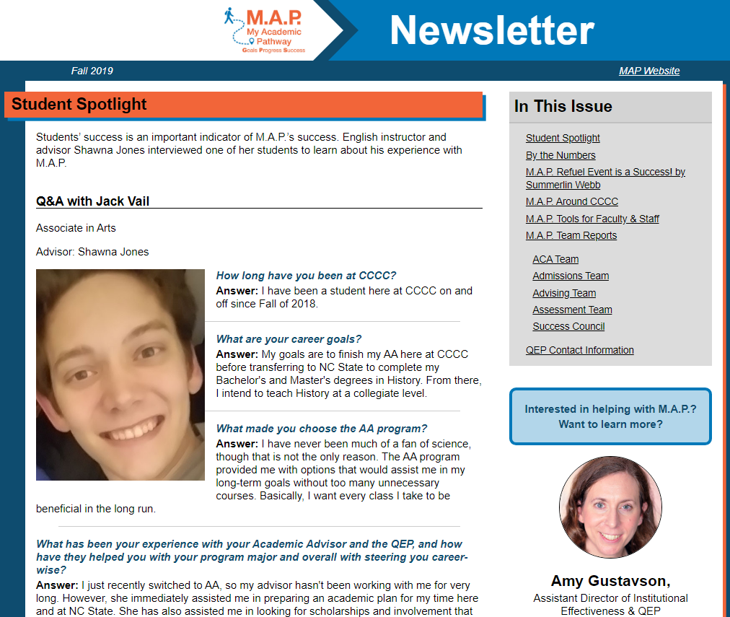

- In October 2019, the M.A.P. Admissions Team held focus groups with students who were referred to a Developmental Faculty Member or Career Counselor to get career support. They did this in order to improve the referral process based on students’ feedback. They found that students were very happy with the current Admissions referral process. They had no suggestions for change.

The M.A.P. Admissions Team also held a training and check-in meeting for Developmental Faculty Members (DFAs) and our Career Counselor in October 2019. They discussed how the referral process is going and how to best support referred students. They decided to automate the referral process in order to more quickly connect students with DFAs and Career Counselor.

- The M.A.P. Advising Team started a series of 30-minute drop-in advising trainings via Blackboard Collaborate in January 2020. The “Advising Short Sessions” include a 15-minute presentation and 15 minutes of Q&A with attendees. The live sessions are recorded for later viewing and topics are selected by CCCC advisors.

CCCC Social Sciences Instructor Dave Malenick presented the first “Advising Short Session” entitled “Breaking the Ice” on January 16, 2020.

- Shawna Jones, Success Council Chair, held student focus groups in Chatham, Harnett, and Lee counties in November 2019. Students shared insights into campus resources, student activities, My Academic Pathway, academic planning, advising, and the transfer process. The qualitative feedback was analyzed and shared with members of the M.A.P. Leadership Team to help with future planning.

- The M.A.P. Assessment Team analyzed 2017-2020 M.A.P. assessment metrics. Selected results include:

- Percentage of students who selected a program of study consistent with their RIASEC interest assessment increased 15% for the second cohort compared with the first cohort.

- 92% of students understand the role and importance of faculty advising

- ACA 122: College Transfer Success is one of the three main elements of My Academic Pathway. The course was revised in Fall 2018 in preparation for the merging of ACA 115 and ACA 122. Student course success rates increased 6% for ACA 122 over three years. The percentage of students enrolling in an ACA course during their first two terms also increased 6% over three years.

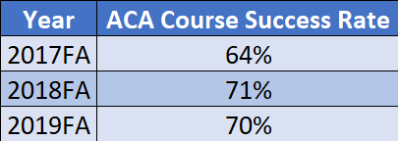

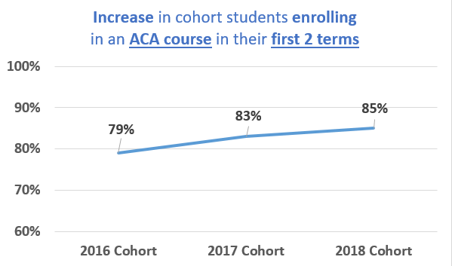

.
STRATEGIC PLANNING AND GPS

The Planning Council continues to meet regularly and is nearing completion of our new strategic plan. At recent meetings we worked with our proposed Focus Areas and Objectives to develop Key Performance Indicators (KPIs), Targets, Strategies for improvement, partners, and potential challenges. We also drafted a revised Mission statement and are working to finalize revised Values, with input from faculty, staff, and students.

The Planning Council was delighted to incorporate input from the Board of Trustees’ SWOT Analysis, which the Board completed during its November retreat. A summary of the Board’s SWOT Analysis appears below:
Results of Board of Trustees SWOT Analysis:

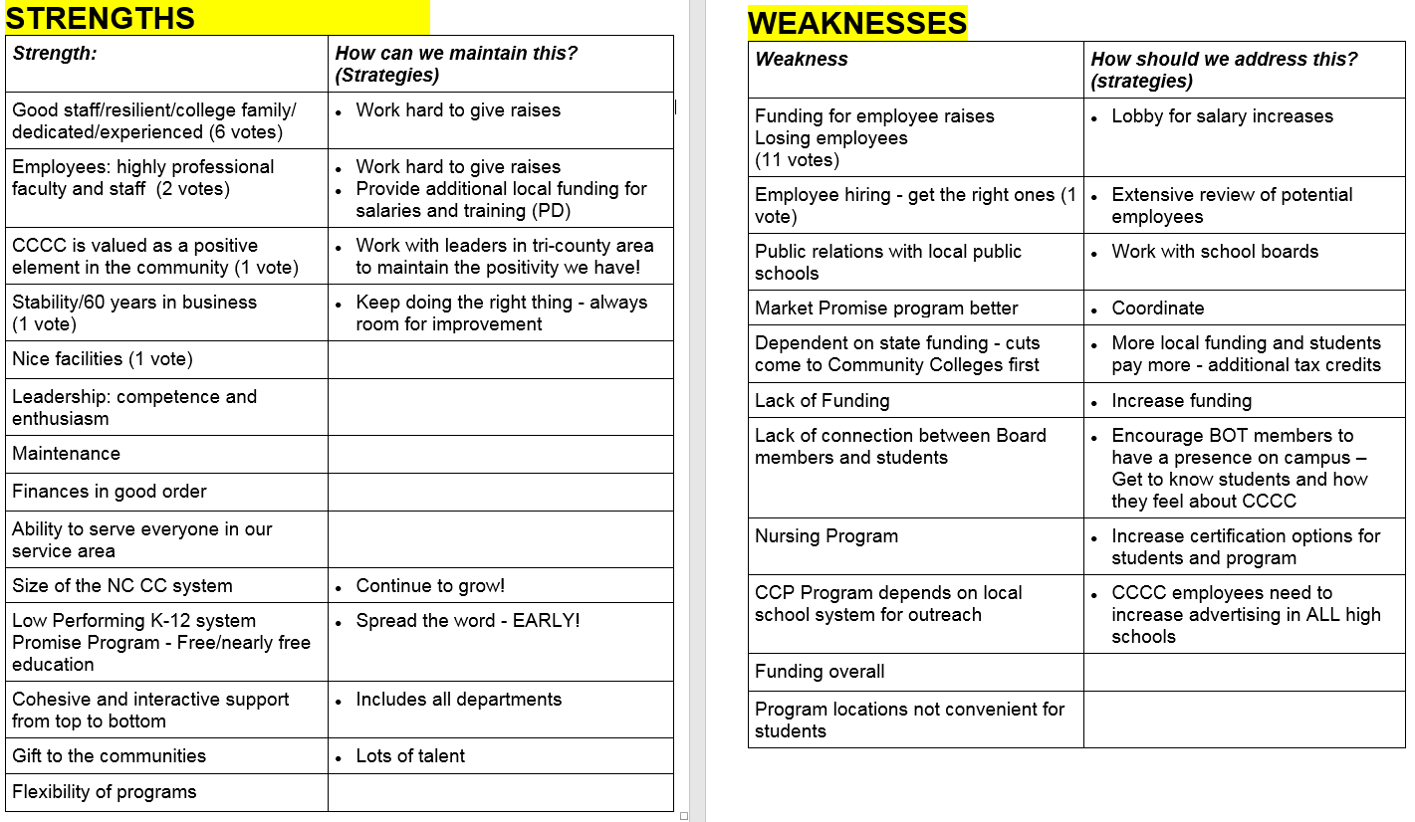

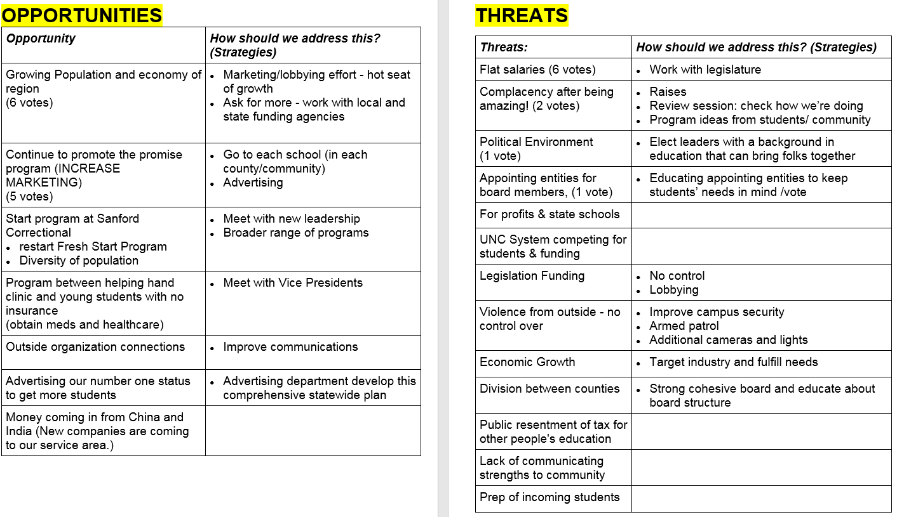

Institutional Effectiveness & Research staff conducted two activities at the all-employee Professional Development Day in December, to obtain input for the new strategic plan:

- All employees participated in a Beach ball Brainstorming activity in groups at their tables, to provide input on how CCCC can best support our Employees (Focus Area 5). Participants repeatedly tossed their beach balls until the music stopped, then answered questions written on the ball, including:
  - How can CCCC improve internal cohesiveness and collaboration?
  - How can CCCC enhance trust among colleagues?
  - How can CCCC improve employee recognition?
  - How can CCCC better support you in your position?
  - How can CCCC best facilitate employee input? and
  - How can CCCC improve communication?
A great deal of useful information was recorded.

- All employees were invited to participate in an Insta-Poll to share their preferred methods of communication. Results include:

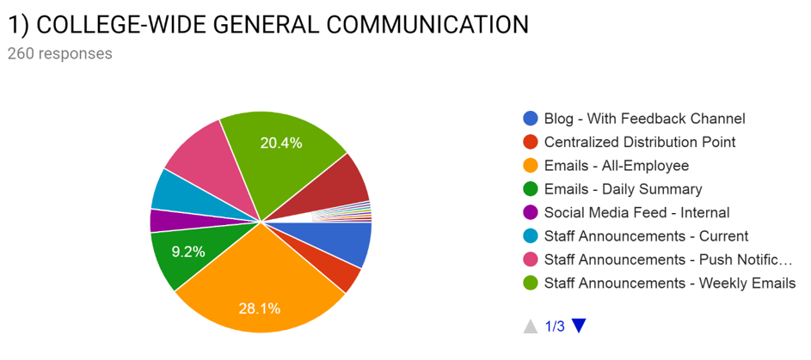

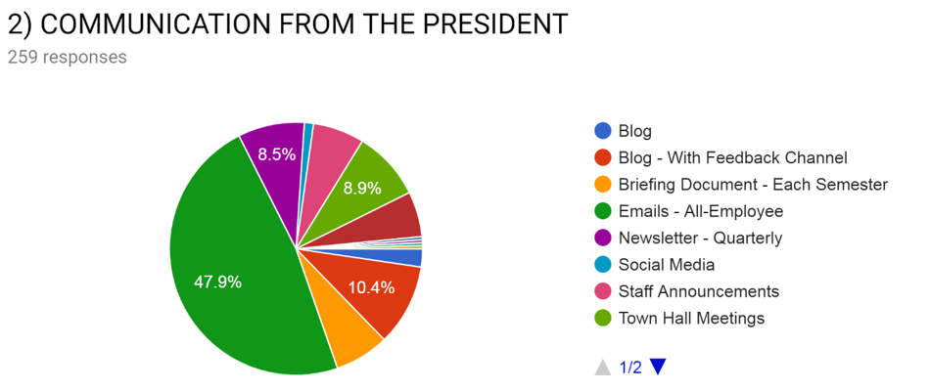

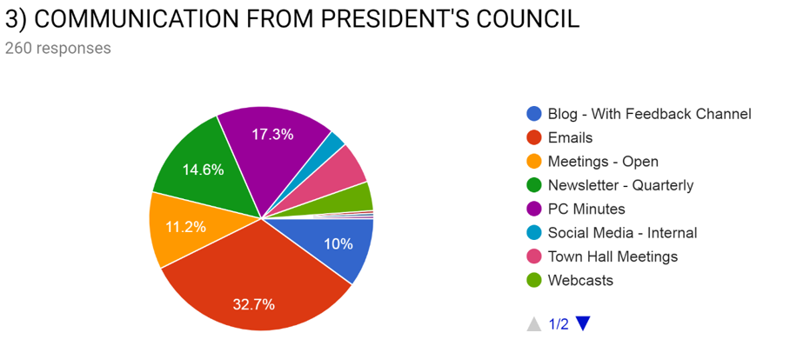

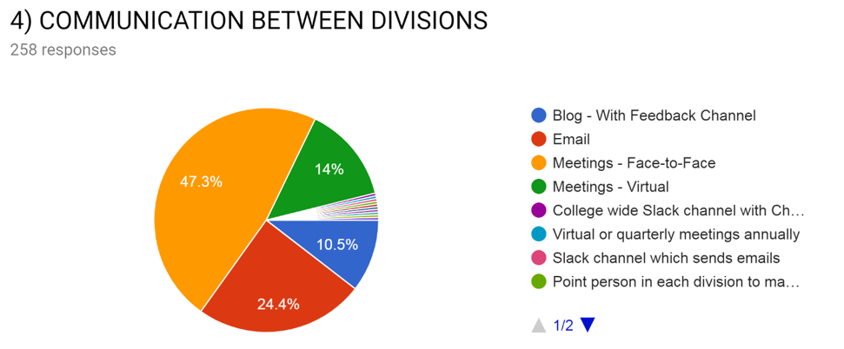

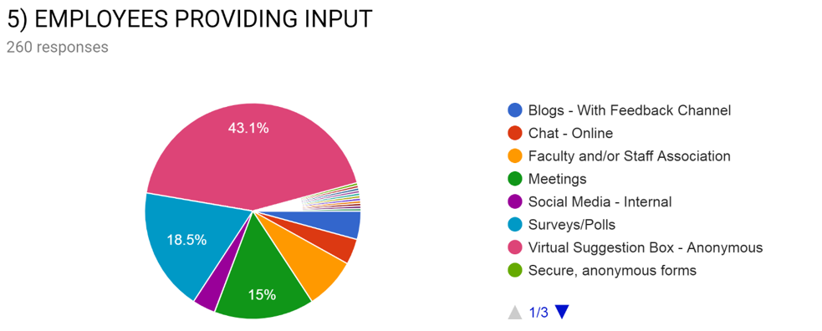

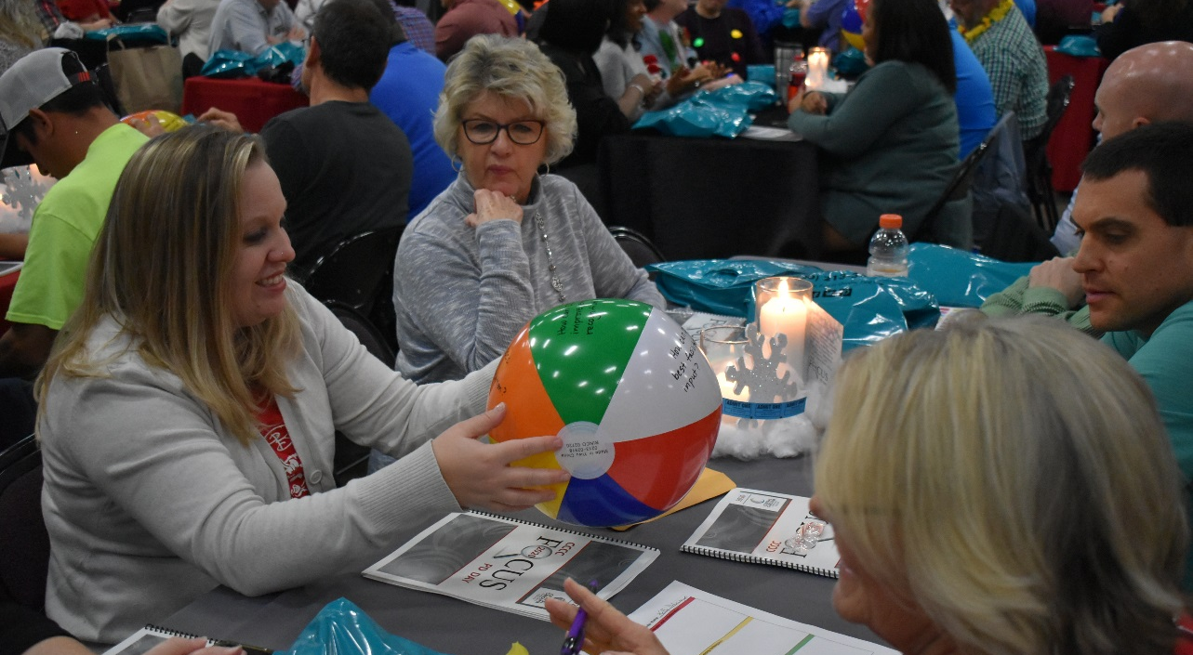
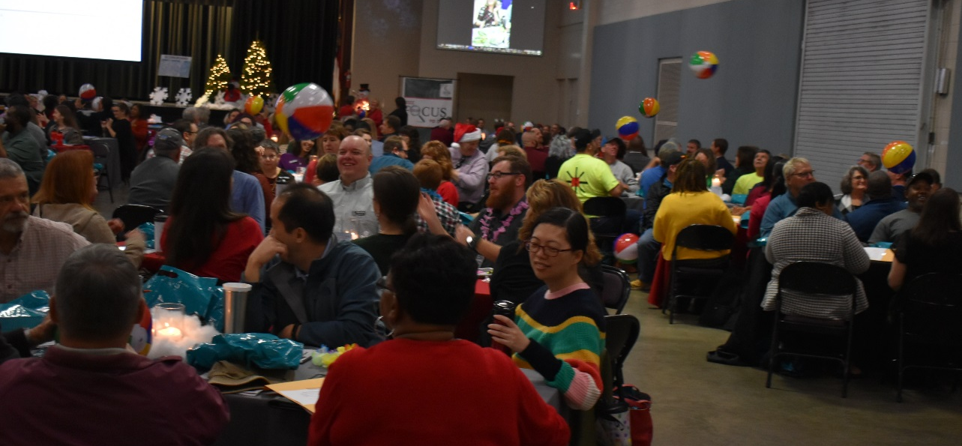

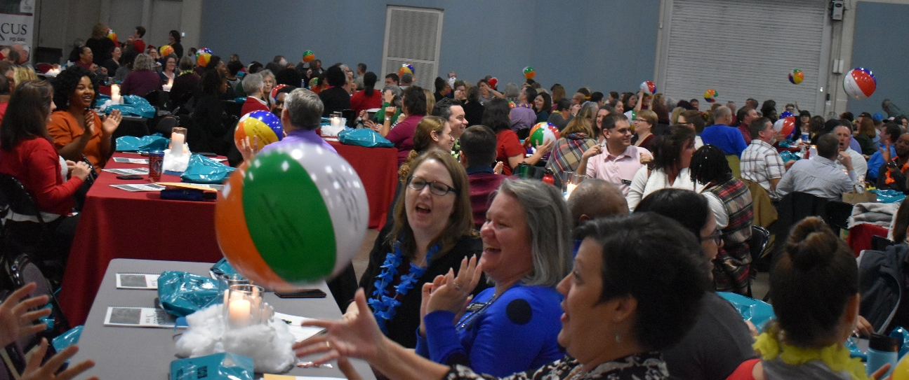

- As part of a visioning exercise to discern new institutional values, members of the Planning Council were asked to think of the ONE COLLEAGUE they believed to be the BEST EXEMPLAR of CCCC, and then to list the THREE KEY ATTRIBUTES that describe that person. The composite results:
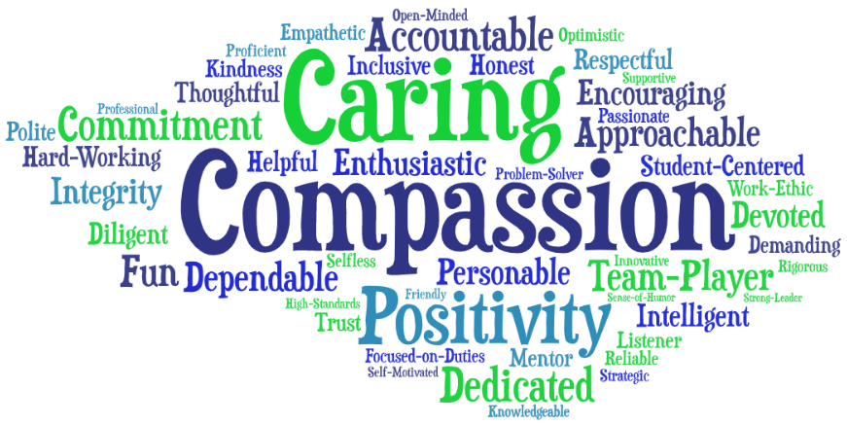
Now that sounds like a colleague that EVERYONE would like to work with or an instructor that EVERYONE would like to learn from!
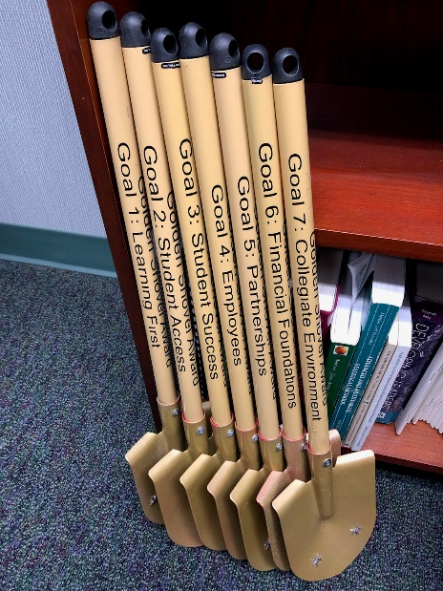
2019 Golden Shovel Learning First Awards
For individuals or teams who save starfish by the shovelful!

Each year the Planning Council joins other faculty and staff to nominate individual employees or departments for the esteemed traveling Golden Shovel awards. There are seven Golden Shovels, one for each Goal in our Learning First strategic plan, awarded to colleagues who inspire us in conjunction with these goals. Based on the Starfish Story that demonstrates that each and every student matters, the awards go to those who save starfish by the shovelful.

Golden Shovels were awarded at the December 2019 All-Employee Holiday Luncheon and Professional Development Day. The nominees and winners are listed below:

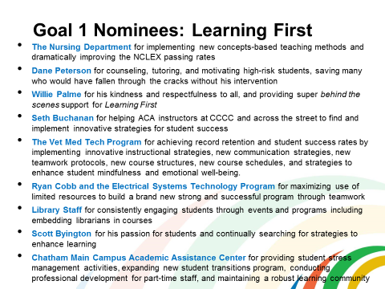

- WINNER: The Nursing Department!

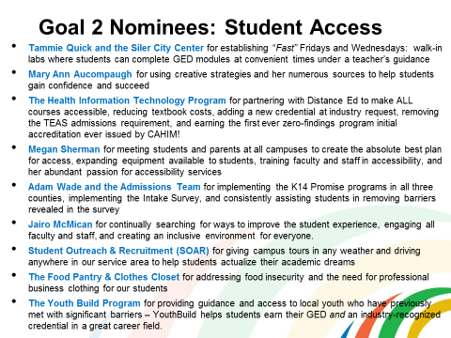

- WINNER: The Youth Build Program!
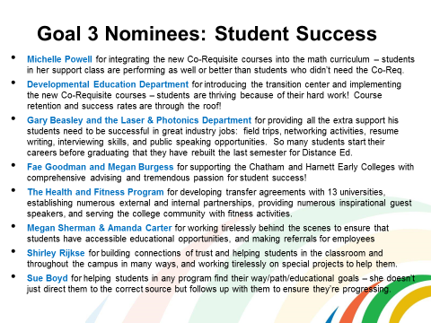

- WINNER: Developmental Education Department!
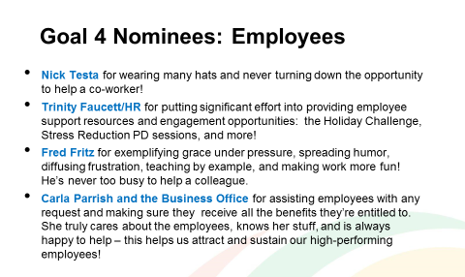

WINNER: Carla Parrish and the Business Office!

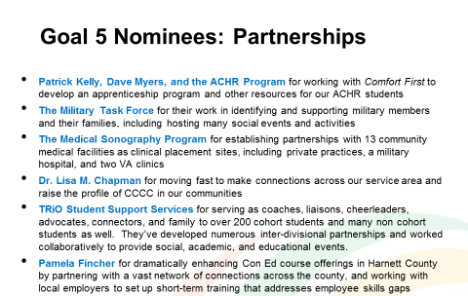

WINNER: Pamela Fincher!

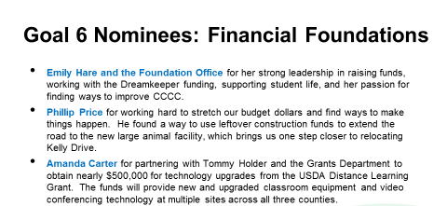

WINNER: Amanda Carter!
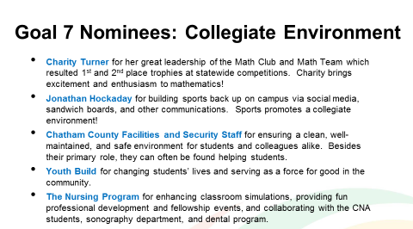

WINNER: Chatham County Facilities and Security Staff!

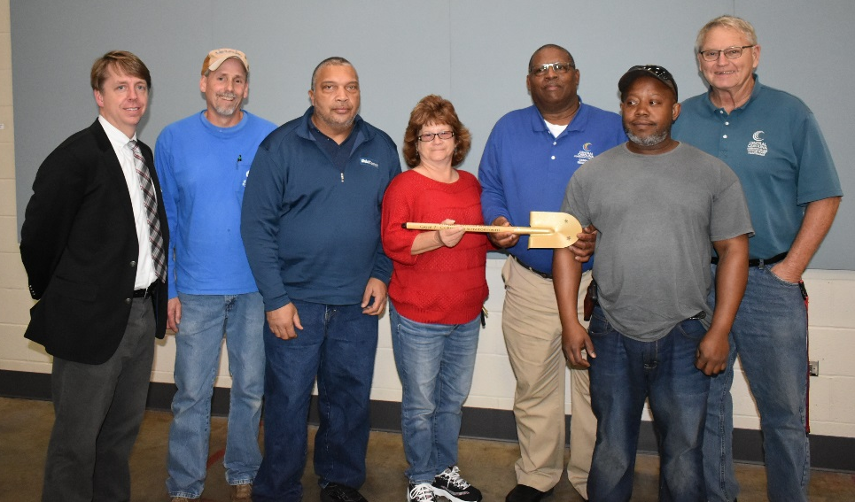

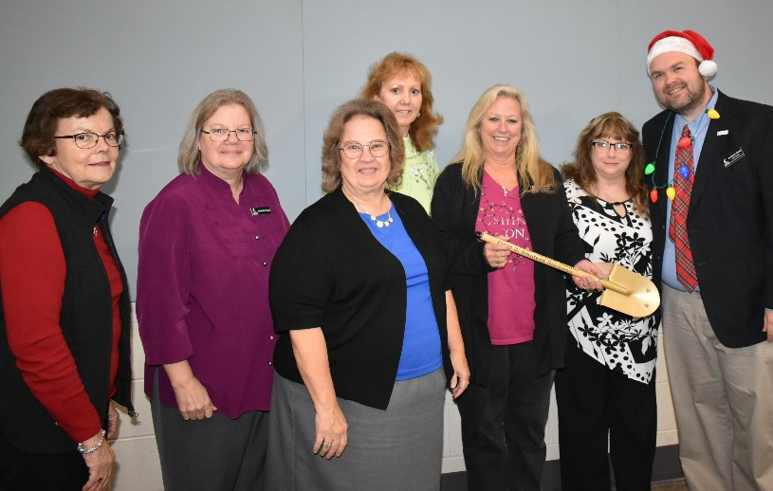
IPEDS

The Integrated Postsecondary Education Data System (IPEDS) is a system of surveys conducted annually by the US DOE’s National Center for Education Statistics (NCES). All institutions that participate in Title IV federal financial aid programs are required to submit information. This information is available to students, parents and the general public through College Navigator as well as several other sites which use IPEDS data. Congress, federal agencies, state governments, education providers, professional associations, private businesses, media, students and parents can utilize IPEDS data to gather information on various institutions.

CCCC chose a designated Comparison Group in 2011, comprised of other NC community colleges of similar size and demographics. In fact, CCCC’s 2010 Fall FTEs were equal to the Comparison Group average at that time:

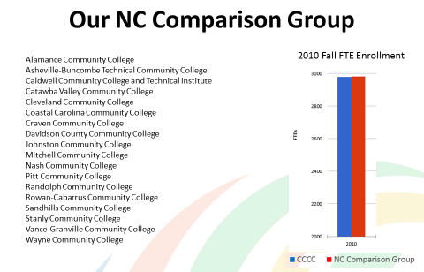

However, during subsequent years, CCCC’s enrollment has continually outpaced that of our Comparison Group:

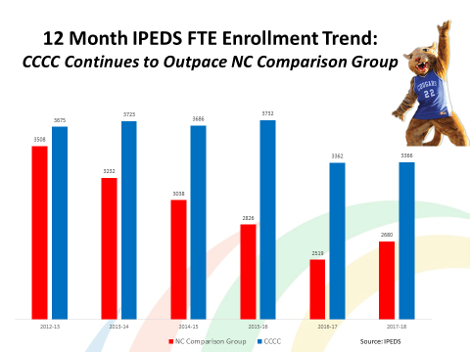
Our most recent detailed enrollment figures continue to outpace our Comparison Group:

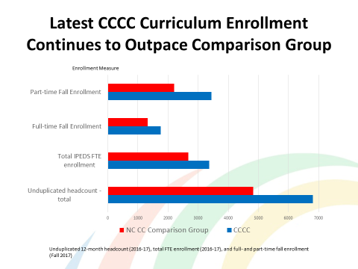

The number of credentials we award continues to exceed that of the Comparison Group:

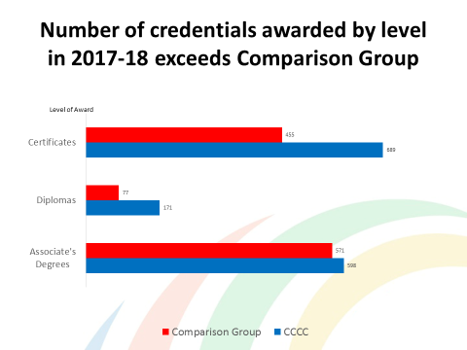

CCCC’s Fall-to-Fall student retention rates continue to outperform our Comparison Group:

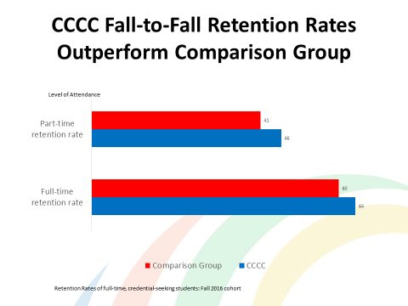

Although retention rates dipped for both CCCC and our Comparison Group, possibly due to low unemployment rates:

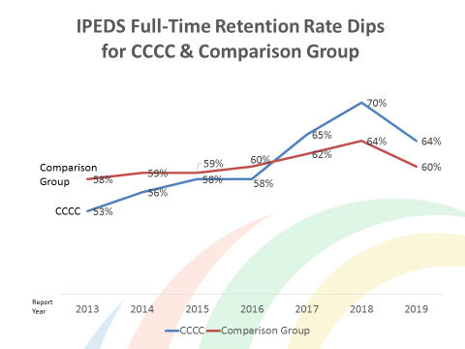

CCCC’s Graduation Rate for First-Time Full-Time students continues to increase at a phenomenal rate (both lines below represent CCCC – one is 100% time and the other is 150% time graduation rate.)

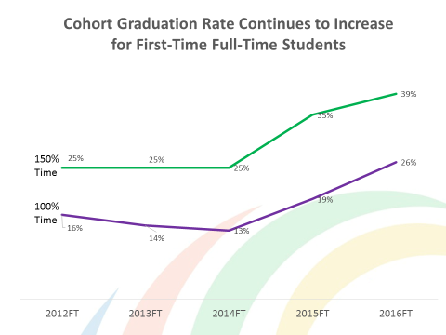

INSTITUTIONAL RESEARCH
Institutional Data
The IER department has continued to support the college community by providing data and analysis by request to assist areas within the college in making data informed decisions. Recent requests have included things such as, retention, success rates, enrollment, FTE, success comparison, program data and equity data.

Student Intake Questionnaire
The Intake Questionnaire, piloted in the fall term, has been completed by nearly 1,500 students. This questionnaire is designed for incoming students to complete and share any challenges or barriers they may be facing. Once completed, a team of staff including admissions and success coaches, reach out to students who indicated that they had barriers and/or requested additional information on resources. The goal is to identify and help students address barriers early in their education so that they have the necessary tools to reach their academic goals. Initial results show:
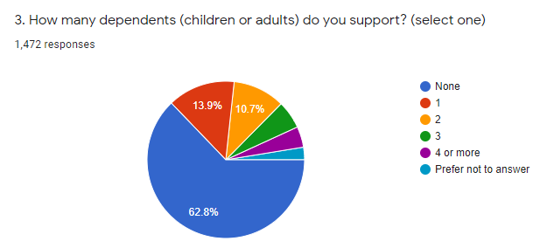
- Almost 35% of students who have completed the questionnaire by January 16, 2020 have 1 or more dependents.
- More than 10% of respondents indicated that they had mental health obstacles.
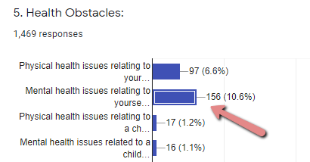

- More than 80% of respondents said they work while attending school, while approximately 50% work at least half time.

Finish First & Retention Efforts
The IER department, in partnership with the student learning and student services divisions, continues to use the audit tool that identifies students who are close to earning any credential or have already earned one but not applied for it. Using the Finish First audit tool, each term IER creates the following lists:
- Potential Graduates both enrolled and not currently enrolled who have not applied to graduate.
- Students within One Semester of graduating.
Results from the first several deployments of this tool identified hundreds of students who had earned a credential but never applied for graduation. The Registrar’s office validated the findings and reached out to all identified students to make arrangements for awarding their credentials.
In addition to the Finish First tool, IER runs retention reports for credential seeking students who were enrolled in one term and had not yet registered for the next. The Student Learning division then provides outreach to assist these students in registering if they choose.

Data Dashboards
The CCCC data dashboards continue to be widely used. These dashboards are designed to provide data updated daily and allow users to drill down and filter the data as they choose.
- The CCCC Data Dashboards are available on the intranet have been updated to include:
  - 2020SP Data
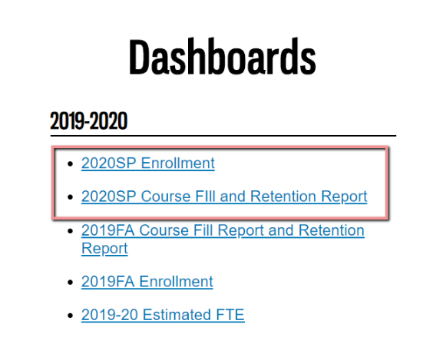
  - Realigning the academic for FTE (now includes Summer, Fall, Spring vs Fall, Spring, Summer)

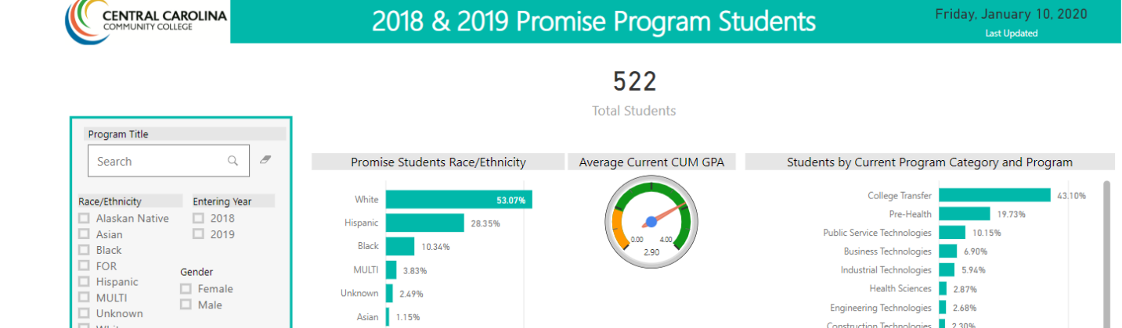
- Additional dashboards are being created for individual departments by request. Examples of these include a disaggregated success rate dashboard and a dashboard showing outcomes of Promise Program students..

Annual Surveys

- An ad hoc committee continues to review and update all annual institutional surveys. The initial focus is on student surveys and will then continue to review employee surveys.

- The Student Financial Wellness Survey, administered by Trellis, was conducted this fall. This survey was done at no cost to the college and will give us a more thorough understanding of the financial wellness of our students. In addition to the summary report for the college, we will receive benchmarked data from institutions similar to CCCC.

- The annual Enrolled Student Satisfaction survey was revised and administered during the Fall term. Results and trends are currently being analyzed and will be presented to PC.

- The 2019 Employee Climate survey was administered during the Fall term and initial results were shared with the president. A qualitative analysis is currently being conducted and full results will be shared with PC. Some interesting results from this survey include:

  - 99% of respondents indicated that they understood how their job impacts the mission of the College.

  - 95% of those who responded believe that current CCCC activities reflect a strong focus on students.

  - 94% believe the College encourages developing new ways to serve our students

  - More than 90% of respondent believe CCCC is a positive working environment and would recommend it as a good place to work.

Annual Surveys- Service Area Satisfaction Awards

The annual awards for service area satisfaction were announced at Professional Development day in December, 2019. This year, due to a change in survey distribution, there were awards for three surveys.

- Winners based on the Enrolled Student Satisfaction Survey 2019-20
  - 1st Place-Career Services- 97.4%
  - 2nd Place-Library Resources- 97%
  - 3rd Place- Accessibility Services- 96.9%
  - Most Improved- Career Services

- Winners based on the Enrolled Student Satisfaction Survey 2018-19
  - 1st Place-Accessibility Services-97.9%
  - 2nd Place-TRIO- 97.5%
  - 3rd Place- CCCC Advertising-97.4%
  - Most Improved- Registration

- Winners based on the Employee Satisfaction Survey
  - 1st Place- Civic Center -99.5%
  - 2nd Place- Business Office- 99%
  - 3rd Place- Library-98.5%
  - Most Improved - Professional Development

